**Branch Predictor Report**

**Introduction:**

In this lab we implemented the branch predictor mentioned in the **Extra Credit** for the dynamic prediction and a static branch predictor. The dynamic prediction is based on two components of the branch predictor. The first is the branch target buffer and the second is the global branch predictor with a global history register which can record the last two instances of the branch instruction. Branch target buffer simply store the program counter of a branch that is taken and its target address. The pattern history table in the global branch predictor is addressed using the lower 10 bits of the program counter and the global history register combined. That means different global history results in different prediction of the same branch.

**Illustration of instructions:**

**beq, bne and j**

The instructions that are involved are beq, bne and j. These are the only three instructions that will trigger that branch predictor. There program counter is sent to the predictor at fetch stage, and the predicting gets corrected in the decode stage. The decode stage logic is modified so that it sends out a signal is_bjD whenever a branch or a jump instruction is at the decode stage. This signal is sent back to the branch predictor directly, so the branch predictor can know the identity of the instruction currently at the decode stage. Use signals like this some other signal, the branch predictor will predict correctly after some warming up.

**Design methodology:**

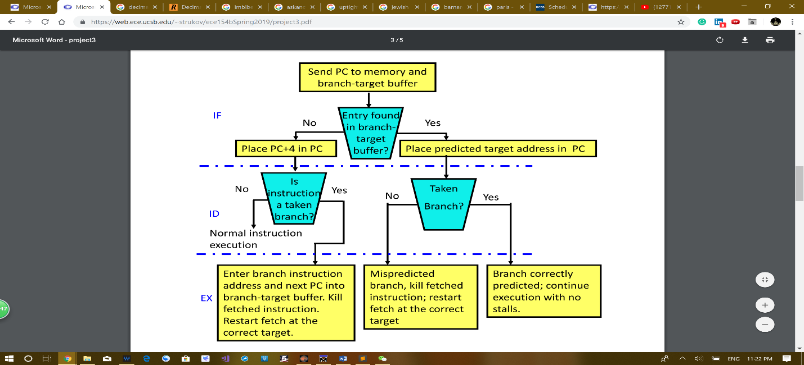We implement the design in the **Extra Credit**, which is target address cache with 2^3 entries and decoupled branch target history table with 2^12 entries. The target address cache and the target history table are implemented as separate module in the branch prediction module. The target address cache, which in our code is call branch target buffer, is implemented according to this picture below, which outputs two signals, “hit” if the tag of the pc is in the cache, and “target_pc”, which is the predicted pc stored in the yellow column of the target address cache.

The updating the target address cache follows the diagram above on the right.

The target history table module, which we call it in our code global history predictor. This module includes the global history register, which in our code is called branch history register.

The two-bit finite state machine is stored in the cells of the pattern history table, which is in the global history predictor. The two-bit predictor finite state machine is achieved by adding one or subtracting one when the branch is taken or not taken. If the state is already 3 or 0, 1 will not be added or subtracted from it. The address of the pattern history table if created by appending the two-bit value in the global branch history register to the last 10 bits of the current program counter.

The design of the data path is also modified. Two extra signals are added to the fetch stage and get propagated down to the decode stage. They are “hit” and “pred_bj”. The first one tells you whether the cache got a hit in the fetch stage and the next tells you whether the global branch predictor predicts this branch or jump will be taken. Also, two signals are added to the decode stage of the pipeline. They are “is_bj” and “real_bj”. The first tells you whether the instruction in decode stage is a branch or a jump, the next tells you whether this branch needs to be taken in reality.

**Step1:** Static branch prediction technique.

In this step we are told to implement a static branch prediction module with “always not taken” policy. The MIPS code used for testing is the same as the one used in step2, so see step2 for the code and the MIPS program. The way we implement the static branch predictor is just to make the hit condition in the dynamic branch predictor always zero. The code in the dynamic branch predictor looks like this

assign hitF = v[indexF] & (tagF == b_pc_tag[indexF]);

In order to achieve the behavior of the static branch predictor we change this line of code to this

assign hitF = v[indexF] & (tagF == b_pc_tag[indexF]) & 0;

This make the branch target buffer never hits and place pc plus 4 as the next pc every time. As you can see from the two waveform below, “always not taken” static branch predictor which takes 1755ns to finish the whole program is much slower than the dynamic branch predictor which takes only 1535ns.

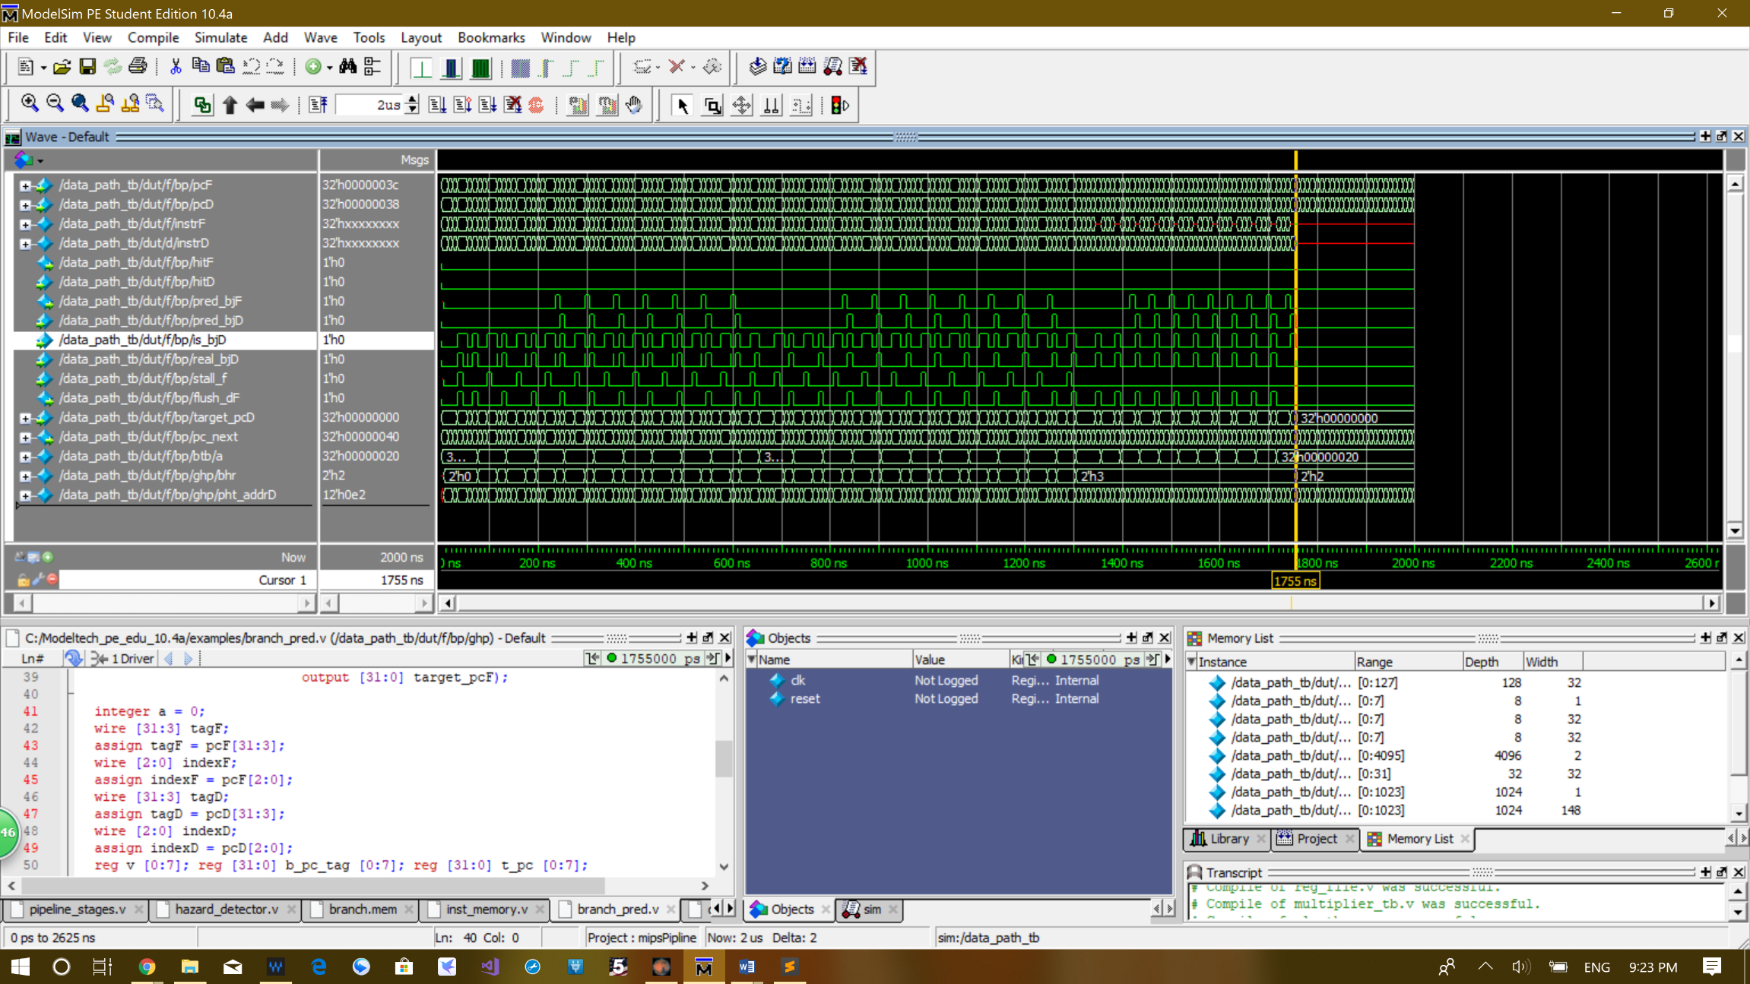The waveform below is the program run on static “always not branch” branch predictor

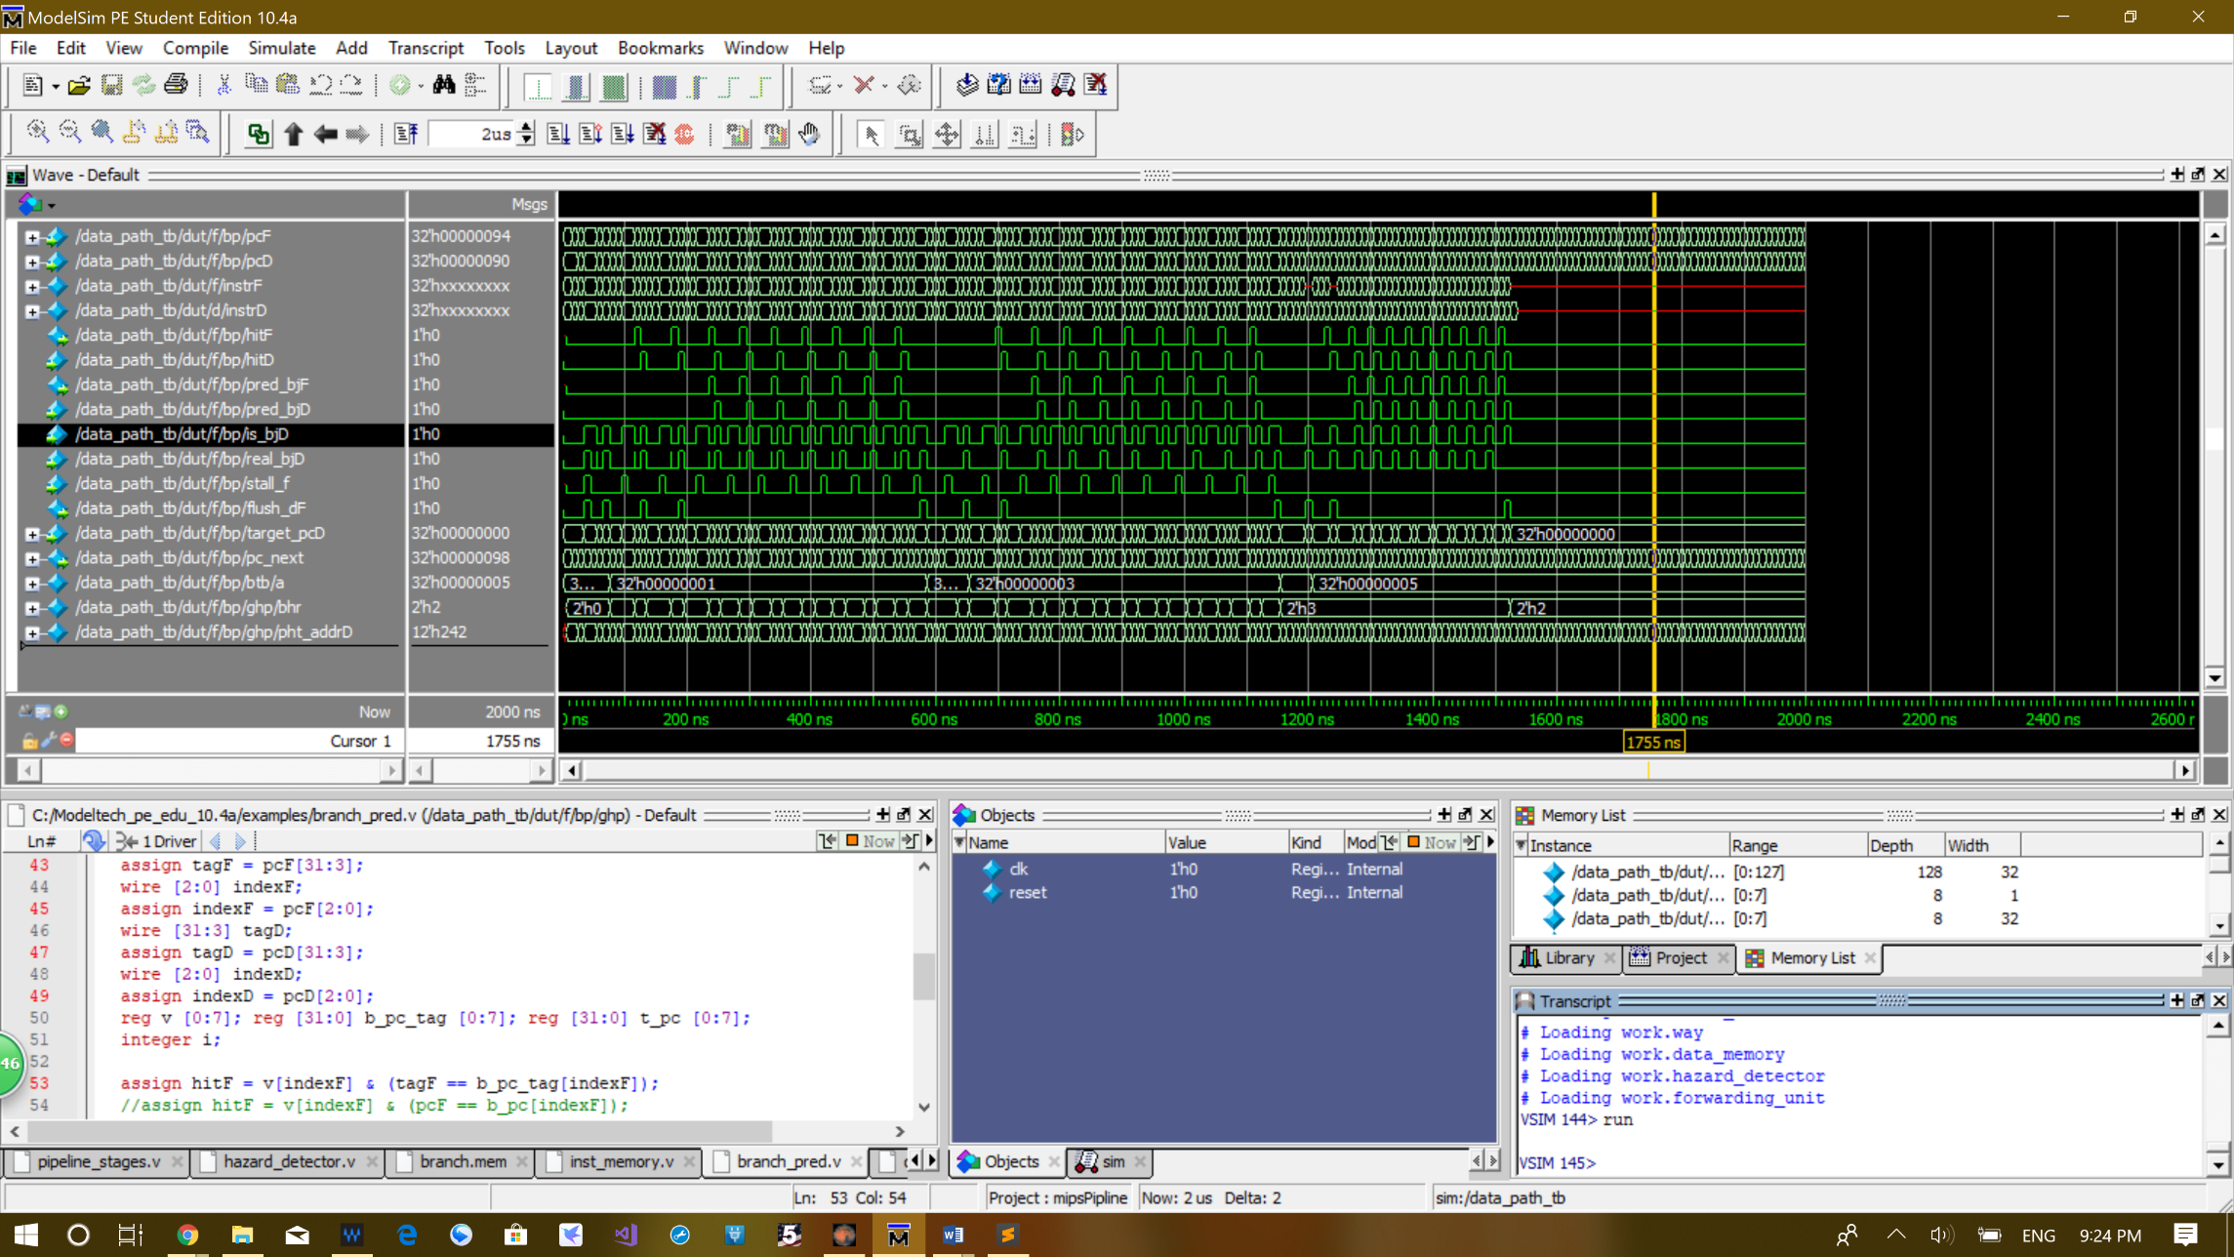The waveform below is the program run on dynamtic branch predictor

How does this improve the performance?

Compering to flush the pipeline every time, which is the behavior of the pipeline without the branch predictor, static predictor does much better. We have in total 50 times a branch or jump instruction is run, in which 18 of them, 9 beq and 9 bne, are not taken, so the static branch predictor is 18 cycles faster than no branch predicting at all.

How do we deal with EX, MEM and WB registers when prediction is wrong?

We do not need to anything to ex, mem or wb stage pipeline register. The only thing we need to do is to flush the decode stage register when the prediction is wrong.

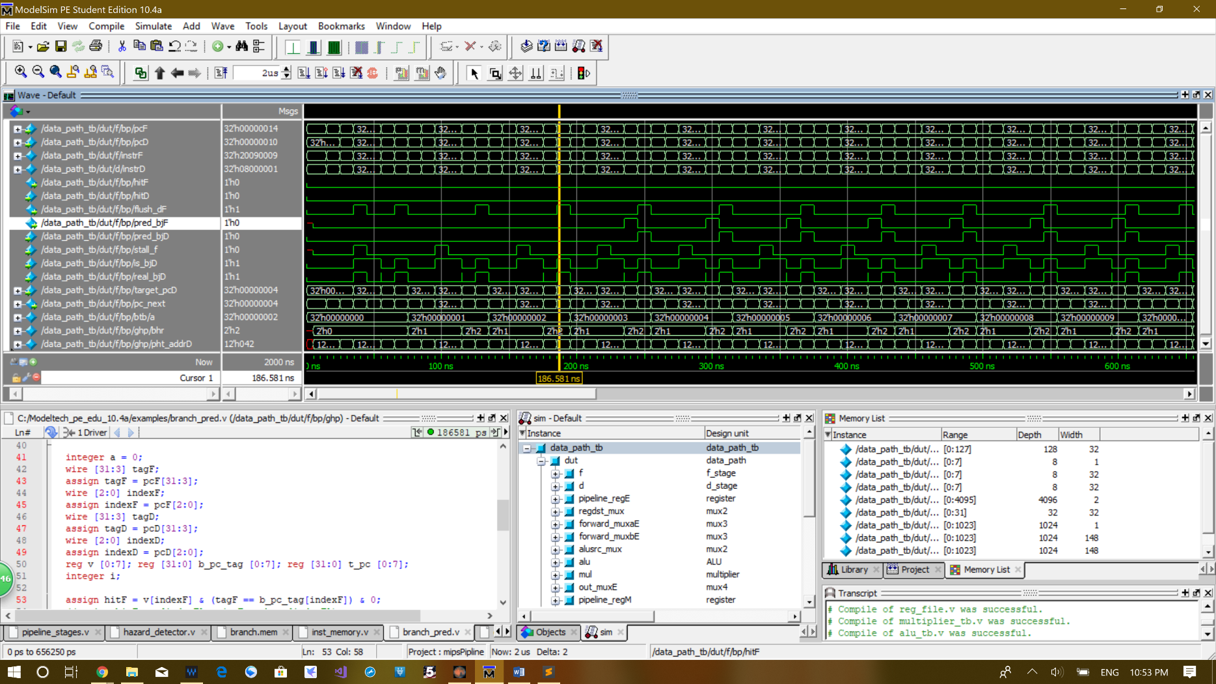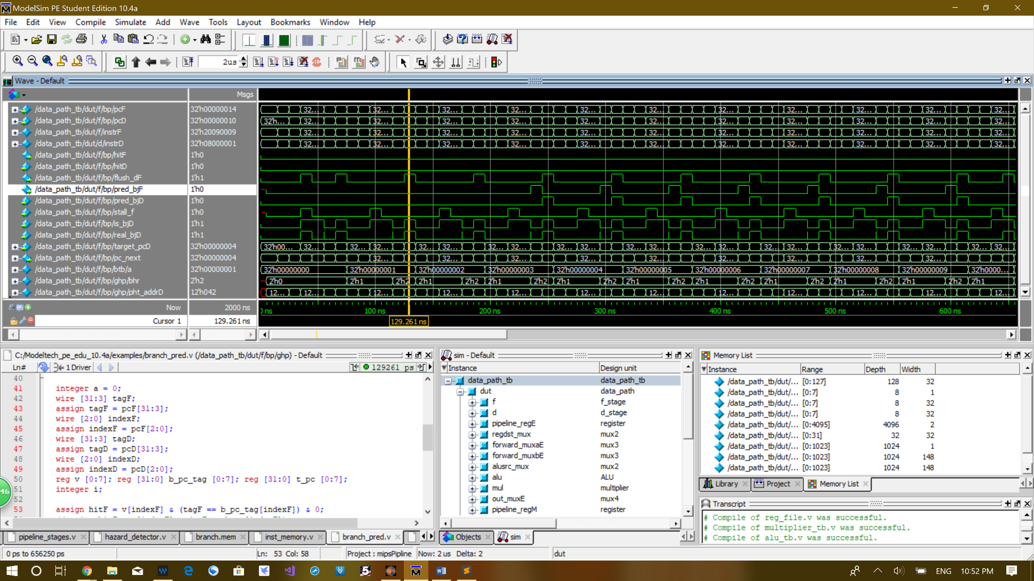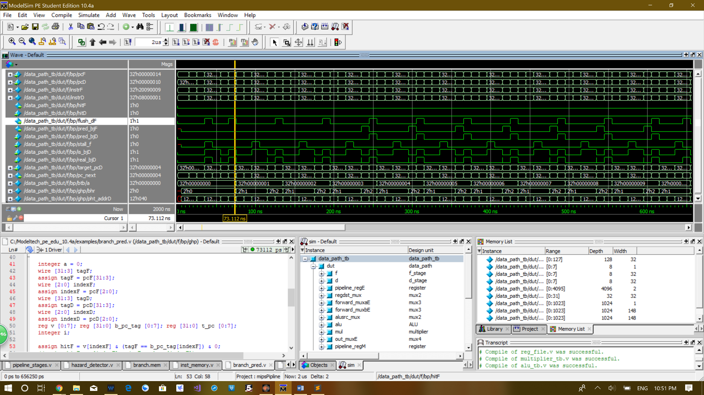**Details of the waveform of the static branch predictor:**

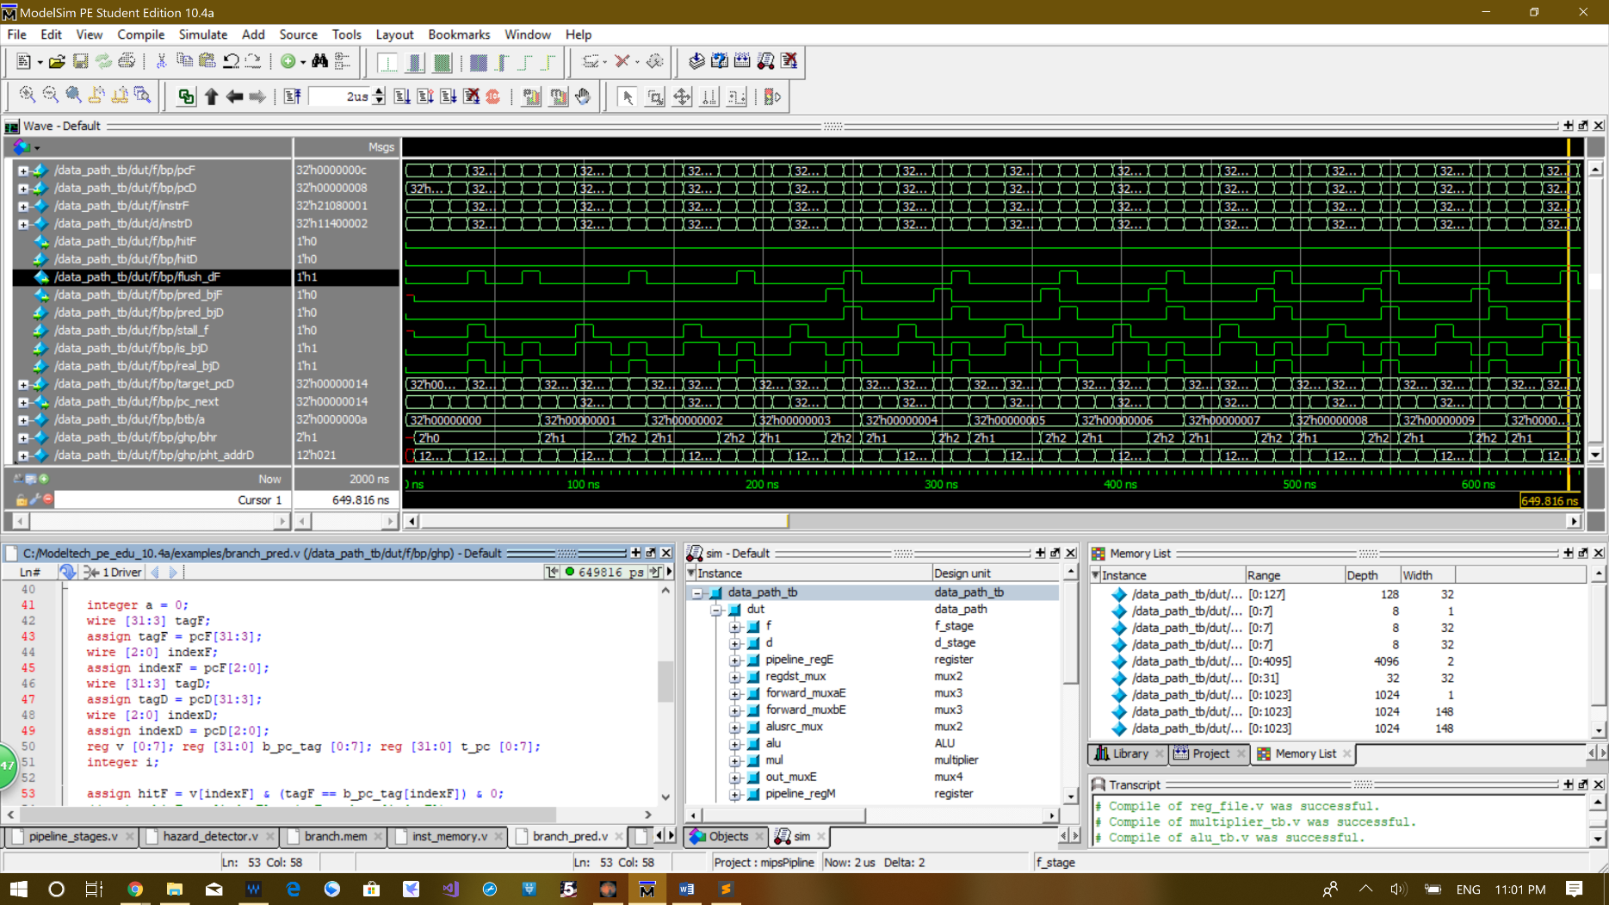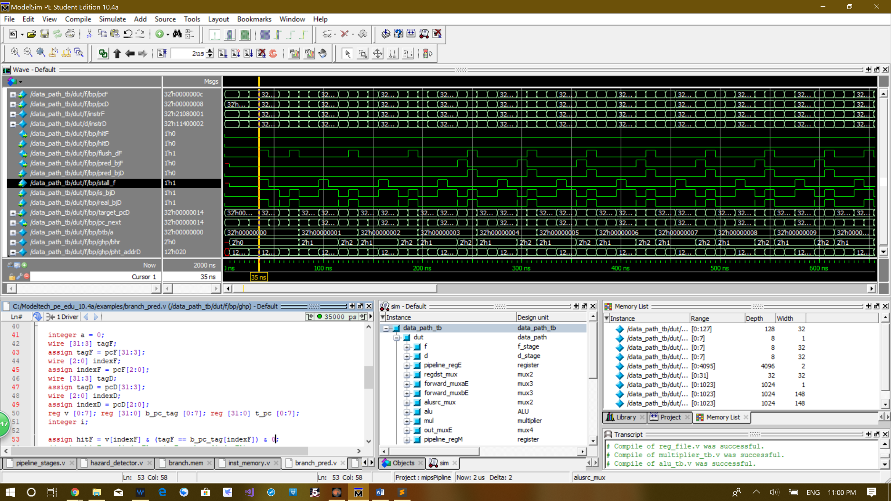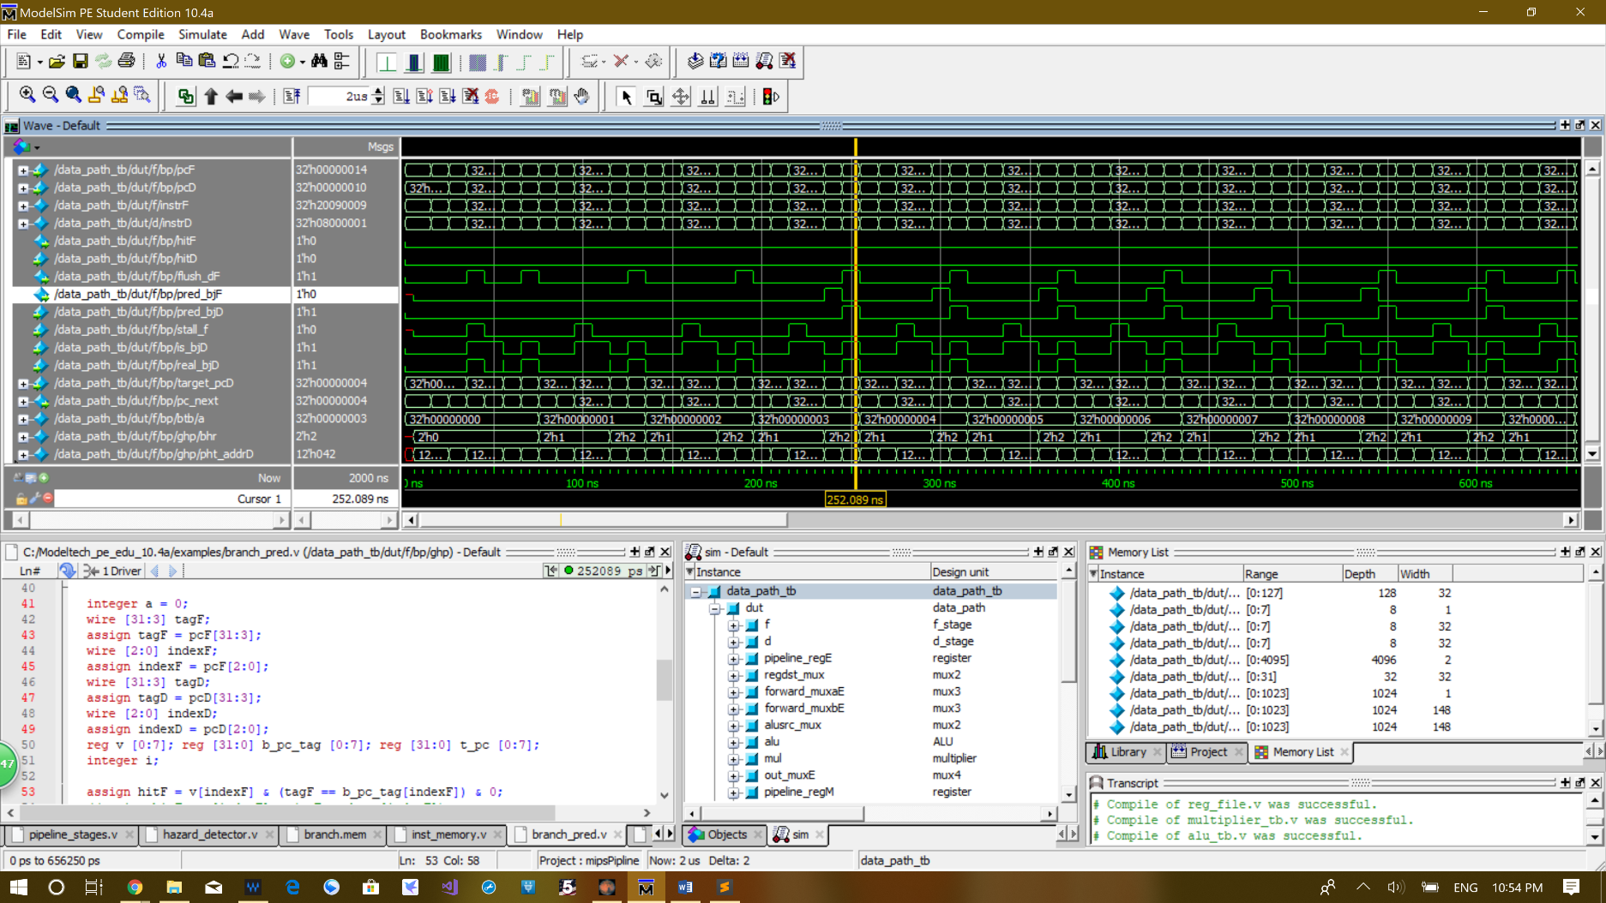The four figures above show the first four jumps the programs takes. As you can see from the numbers Msgs column corresponding to the the position of the yellow cursor, they all have instrD 0x08000001, which is the jump of the first while loop in the program. As you can see the instrD only sustain for one cycle and gets flush in the next cycle. There are in totla 10 jumps in this while loop. These corresponds to the 10 flushes in the four wavforms above. As you can see, there are no stall concurrent to any of these flushes during the jump, so they all get sucessfuly flush and the intruction changes in fetch stage in the next cycle.

The position of the cursor in the two figures above corresponeds to the the first time the beq instrution is in the decode stage and the last time beq instruciton is executed in this while loop which loops 10 times. The flush corresponed to the first time the beq instruction is in the decode stage. The decode stage is not actually flushed, because our pipeline register take precedence of stall over clear. As you can see, the stall signl is high at the same time. This is because the slt calculation is still in executino stage and the decode stage have to stall for one cycle to wait for the corrent value to be forwarded back form outM. The reason why the first time the fush is trigered when the beq clearly does not need to branch is that the execution stage signal is because the outM, which is the place the result is been fowared back to decode stage, is currently all zeros right after the reset at the start of the program. This zero value appears to be equal to the register value which is also zero right after the reset, since the corrent regiter value have not yet been written back. This the the reason why flush is triggered at the start because zero equals to zero, and it seems that the branch needs to be taken. But after the right value comes at the next cycle, the flush signal immediately comes back to zero, which means nothing is flushed.

The seconde picture in which the cursor is at the end of the picture corretly shows the instruction in the decode stage being flushed. This this the last beq. This branch is take, but the predictor predict it is always not take so it needs to be flushed. As you can see there is no stall signal at this time and the instruion changes immediately after this cycle, whick mean this is corrretly flushed.

**Step 2 and Step 3:** implement the dynamic branch predictor.

**Code:**

module branch_pred(input clk, reset, hitD, pred_bjD, is_bjD, real_bjD, stall_f,

input [31:0] pcF, pcD, pcplus4F, pcplus4D, target_pcD,

output hitF, pred_bjF, output reg flush_dF,

output reg [31:0] pc_next);

wire [31:0] target_pcF;

branch_target_buffer btb(clk, reset, hitD, is_bjD, real_bjD, stall_f,

pcF, pcD, target_pcD,

hitF,

target_pcF);

global_history_predictor ghp(clk, reset, is_bjD, real_bjD, stall_f,

pcF, pcD,

pred_bjF);

always @(*) begin

if(~is_bjD) begin

if(hitF & pred_bjF) pc_next <= target_pcF;

else pc_next <= pcplus4F;

flush_dF <= 0;

end

else begin

if((hitD & pred_bjD) & real_bjD | ~(pred_bjD & hitD) & ~real_bjD) begin

if(hitF & pred_bjF) pc_next <= target_pcF;

else pc_next <= pcplus4F;

flush_dF <= 0;

end

else if( (hitD & pred_bjD) & ~real_bjD) begin pc_next <= pcplus4D; flush_dF <= 1; end

else if(~(hitD & pred_bjD) & real_bjD) begin pc_next <= target_pcD; flush_dF <= 1; end

end

end

endmodule

module branch_target_buffer(input clk, reset, hitD, is_bjD, real_bjD, stall_f,

input [31:0] pcF, pcD, target_pcD,

output hitF,

output [31:0] target_pcF);

integer a = 0;

wire [31:3] tagF;

assign tagF = pcF[31:3];

wire [2:0] indexF;

assign indexF = pcF[2:0];

wire [31:3] tagD;

assign tagD = pcD[31:3];

wire [2:0] indexD;

assign indexD = pcD[2:0];

reg v [0:7]; reg [31:0] b_pc_tag [0:7]; reg [31:0] t_pc [0:7];

integer i;

assign hitF = v[indexF] & (tagF == b_pc_tag[indexF]) & 0;

//assign hitF = v[indexF] & (pcF == b_pc[indexF]);

assign target_pcF = t_pc[indexF];

always @(posedge clk) begin

if(reset) begin

for(i = 0; i < 8; i = i + 1) begin

v[i] = 0; b_pc_tag[i] = 0; t_pc[i] = 0;

end

end

else if(is_bjD & real_bjD & ~hitD & ~stall_f) begin

v[indexD] <= 1;

b_pc_tag[indexD] <= pcD[31:3];

t_pc[indexD] <= target_pcD;

a = a+1;

end

end

endmodule

module global_history_predictor(input clk, reset, is_bjD, real_bjD, stall_f,

input [31:0] pcF, pcD,

output pred_bjF);

integer b = 0, c = 0;

wire [9:0] pc_lowerF; assign pc_lowerF = pcF[9:0];

wire [9:0] pc_lowerD; assign pc_lowerD = pcD[9:0];

reg [1:0] bhr;

reg [1:0] pht [0:4095];

wire [11:0] pht_addrF; assign pht_addrF = { pc_lowerF[9:0], bhr[1:0] };

wire [11:0] pht_addrD; assign pht_addrD = { pc_lowerD[9:0], bhr[1:0] };

integer i;

assign pred_bjF = pht[pht_addrF][1];

always @(posedge clk) begin

if(reset) begin

bhr <= 0;

for(i = 0; i < 4096; i = i + 1) pht[i] <= 0;

end

else if(is_bjD & real_bjD & ~stall_f) begin

if(pht[pht_addrD] != 3) pht[pht_addrD] = pht[pht_addrD] + 1;

bhr = bhr << 1;

bhr[0] = real_bjD;

b = b+1;

end

else if(is_bjD & ~real_bjD & ~stall_f) begin

if(pht[pht_addrD] != 0) pht[pht_addrD] = pht[pht_addrD] - 1;

bhr = bhr << 1;

bhr[0] = real_bjD;

end

end

endmodule

**code of changed f stage and d stage:**

module f_stage(input clk, reset, hitD, pred_bjD, is_bjD, real_bjD, stall_f,

input [31:0] pcD, pcplus4D, target_pcD,

output flush_dF,

output [97:0] dD);

wire hitF, pred_bjF;

wire [31:0] pc_next, pcF, pcplus4F, instrF;

register#(32) pc_reg(clk, reset, stall_f, pc_next, pcF);

inst_memory imem(pcF, instrF);

assign pcplus4F = pcF + 4;

branch_pred bp(clk, reset, hitD, pred_bjD, is_bjD, real_bjD, stall_f,

pcF, pcD, pcplus4F, pcplus4D, target_pcD,

hitF, pred_bjF, flush_dF,

pc_next);

assign dD = {hitF, pred_bjF, pcF, pcplus4F, instrF};

endmodule

module d_stage(input clk, reset, stall_d, flush_dF, forwardaD, forwardbD, regwriteW,

input [4:0] writeregW,

input [31:0] outM, resultW,

input [97:0] dD,

output branchD, hitD, pred_bjD, is_bjD, real_bjD,

output [4:0] rsD, rtD,

output [31:0] pcD, pcplus4D, target_pcD,

output [156:0] dE);

wire [97:0] qD;

wire [31:0] instrD;

assign {hitD, pred_bjD, pcD, pcplus4D, instrD} = qD;

register#(98) pipeline_regD(clk, reset | flush_dF, stall_d , dD, qD);

wire se_zeD, eq_neD, jumpD;

wire memreadD, memwriteD, regwriteD, memtoregD, regdstD;

wire alusrcD, multD, mult_signD;

wire [1:0] out_selD;

wire [3:0] alu_opD;

controller control(instrD[31:26], instrD[5:0],

se_zeD, eq_neD, branchD, jumpD,

memreadD, memwriteD, regwriteD, memtoregD, regdstD,

alusrcD, multD, mult_signD,

out_selD,

alu_opD);

wire [31:0] rd1D, rd2D;

reg_file rf(clk, reset, regwriteW,

instrD[25:21], instrD[20:16],

writeregW,

resultW,

rd1D, rd2D);

branch_jump bj(eq_neD, branchD, jumpD, forwardaD, forwardbD,

rd1D, rd2D, outM, pcplus4D, instrD,

is_bjD, real_bjD,

target_pcD);

wire [31:0] sh_immD, se_immD, ze_immD, ext_immD;

ls16 lui_sh(instrD[15:0], sh_immD);

signext se(instrD[15:0], se_immD);

zeroext ze(instrD[15:0], ze_immD);

mux2#(32) ext_muxD(ze_immD, se_immD, se_zeD, ext_immD);

wire [4:0] rdD;

assign rsD = instrD[25:21];

assign rtD = instrD[20:16];

assign rdD = instrD[15:11];

assign dE = {memreadD, memwriteD, regwriteD, memtoregD, regdstD,

alusrcD, alu_opD, out_selD, multD, mult_signD,

rd1D, rd2D, rsD, rtD, rdD, sh_immD, ext_immD};

endmodule

module branch_jump(input eq_neD, branchD, jumpD, forwardaD, forwardbD,

input [31:0] rd1D, rd2D, outM, pcplus4D, instrD,

output is_bjD, real_bjD,

output [31:0] target_pcD);

wire equal, branch_cond;

wire [31:0] muxa_out, muxb_out;

mux2#(32) forward_muxaD(rd1D, outM, forwardaD, muxa_out);

mux2#(32) forward_muxbD(rd2D, outM, forwardbD, muxb_out);

assign equal = muxa_out == muxb_out;

assign branch_cond = (eq_neD) ? equal : ~equal; // branch condition determined by beq or bne

assign is_bjD = branchD | jumpD;

assign real_bjD = (branchD & branch_cond) | jumpD;

wire [31:0] se_imm, ls2_out;

signext se(instrD[15:0], se_imm);

ls2 branch_sh(se_imm, ls2_out);

wire [31:0] branch_pc; assign branch_pc = ls2_out + pcplus4D;

wire [31:0] jump_pc; assign jump_pc = {pcplus4D[31:28], instrD[25:0], 2'b0};

assign target_pcD = (branchD) ? branch_pc :

(jumpD) ? jump_pc : 32'b0;

endmodule

**The mips machine code for testing:**

addi $t0, $zero, 0

while1: slti $t2, $t0, 10

beq $t2, $zero, exit1

addi $t0, $t0, 1

j while1

exit1:

addi $t1, $zero, 9

while2: slti $t2, $t1, 0

bne $t2, $zero, exit2

addi $t1, $t1, -1

j while2

exit2:

addi $t0, $zero, 0

while3: slti $t2, $t0, 10

addi $t0, $t0, 1

bne $t2, $zero, while3

**Test bentch:**

`timescale 1ns / 1ps

module data_path_tb;

reg clk;

reg reset = 1;

data_path dut(clk, reset);

initial begin // initialize test

#10; reset = 0;

end

always begin // generate clock to sequence tests

clk = 0; #5;

clk = 1; #5;

end

endmodule

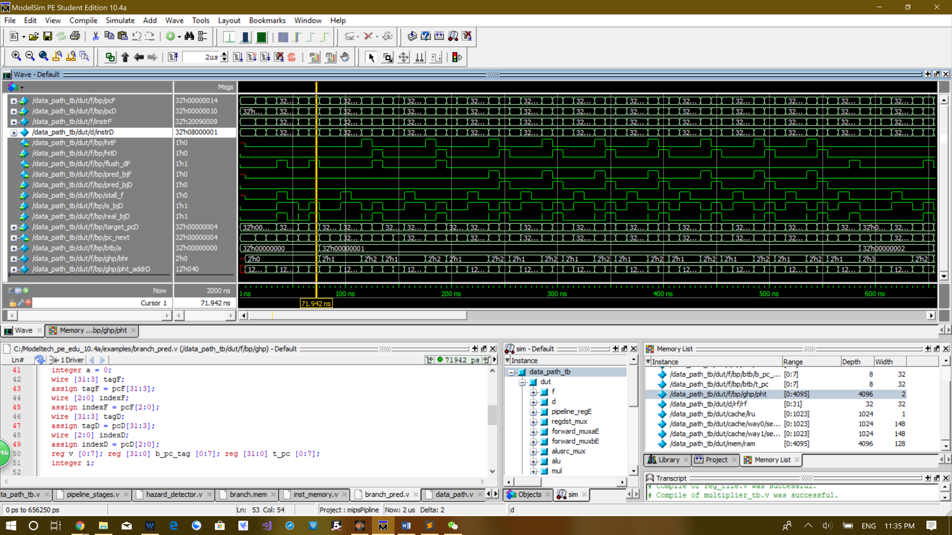**Waveform:**

The value “a” shows the number of branch or jump instruction is stored in the branch target buffer. This is not a signal used for internal control. It is just a signal added to make it easier to show what exactly happened in the branch target buffer. As you can see, the first instruction gets stored in the branch target buffer is a jump instruction. The value of instrD is 0x080000001 which is the first jump instruction. The flush signal is triggered because pred_bjD and hitD are all zeros, which means that the branch predictor predicted “not taken”, so the instruction must be flushed.

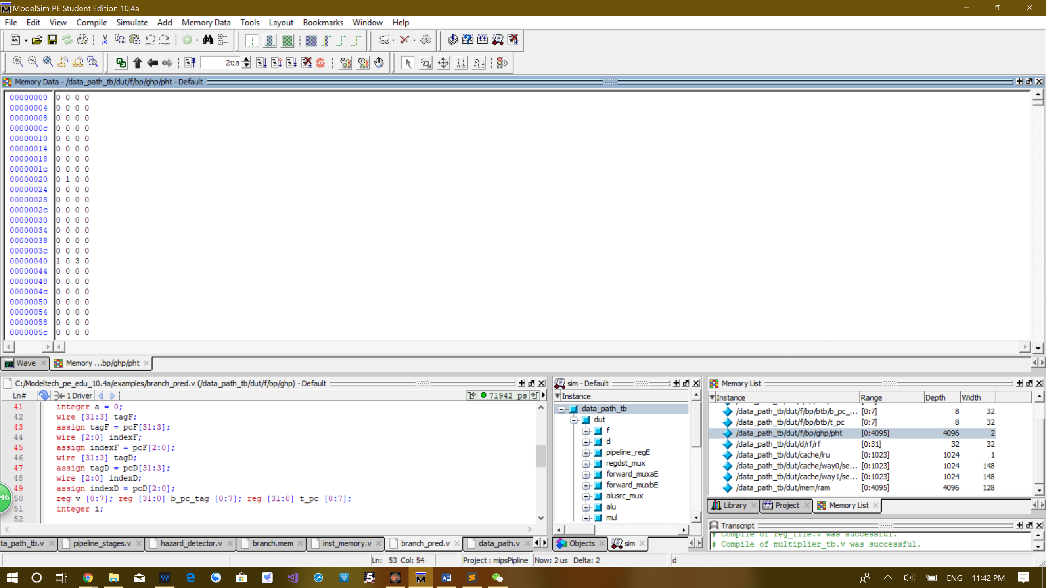

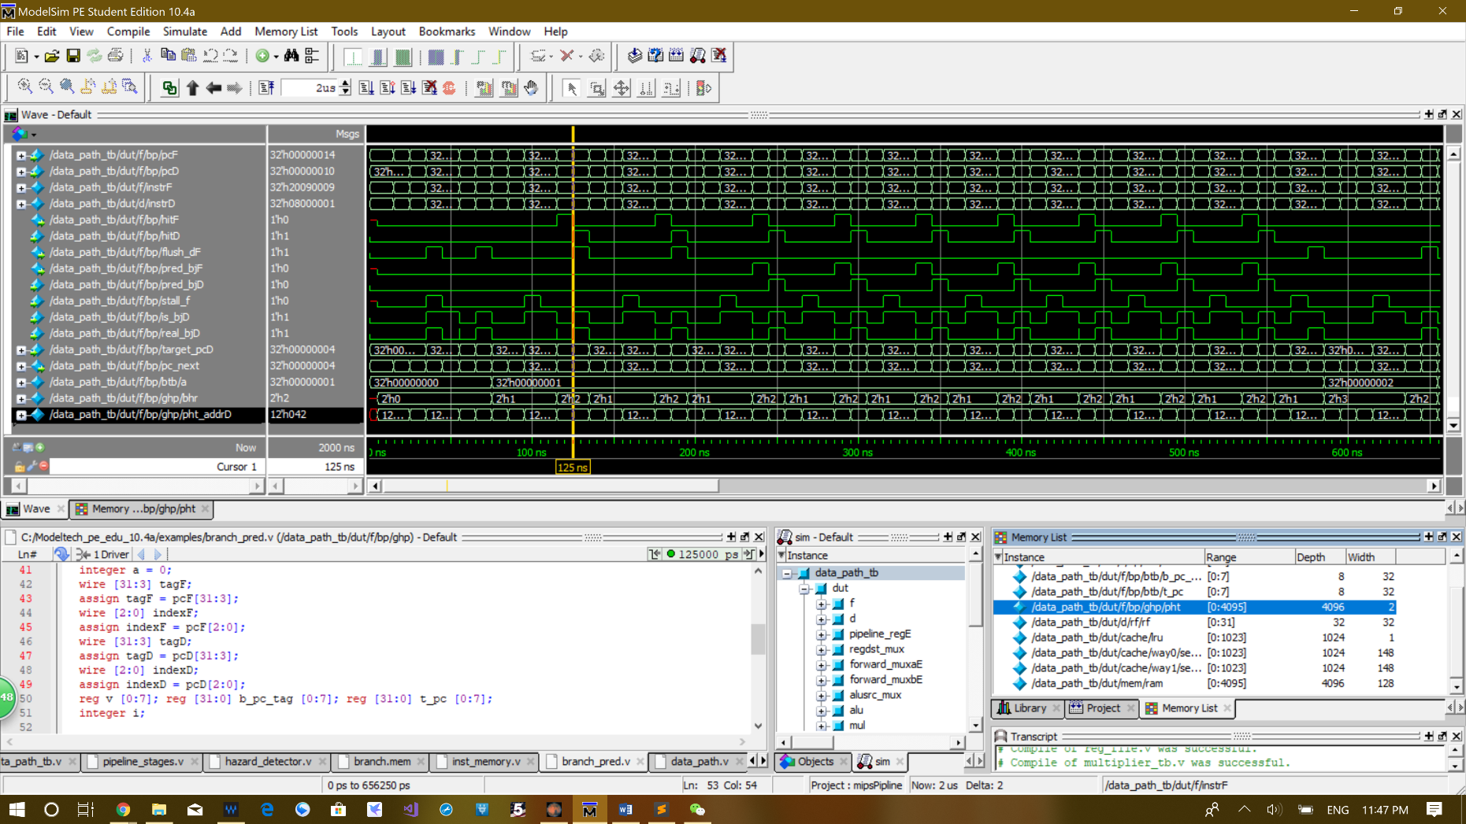You can also see that the value is incremented in the address 40 in the pattern history table. The value 40 is exact the lower 10 bit of the pc value combined with the current bhr value, which is 00. A one is stored in there because this the only jump after no jump or branch in the global hisotry register.

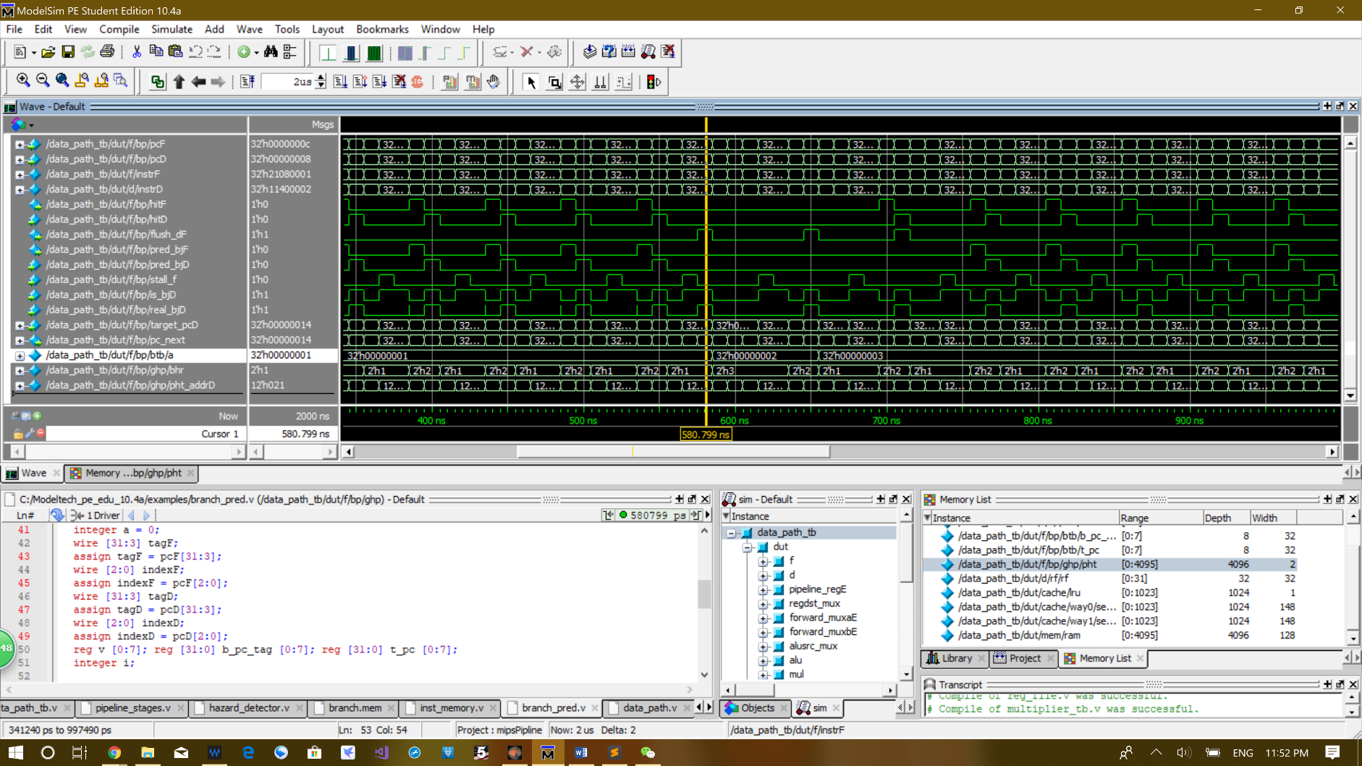The next 9 jumps all get the value in the address 42 of the pattern history table incremented, and the value of that entry become 3 in the end because that the highest you can go. As you can see, the prediction took 3 times to warm up. The space between the yellow cursor and the eventual prediction around 250ns have exactly two jumps in between, at the place where the two flush signals are triggered.

After 10 jumps the initial beq gets triggered and the value is incremented in the address 21 in the pattern history table. The address 21 is exact the combination of the later 10 bits of the current pcD and the 2 bits from bhr combined. The bhr value is 1, that is why it gets that last digit 1 in the address. As you can see the instrD have the value 0x11400002, which is the first branch equal instruction. This instruction only gets store at the end of the first while loop because when at branch is not taken it is not stored in the branch target buffer, so it is stored at the last time, which is the only time it is branched.

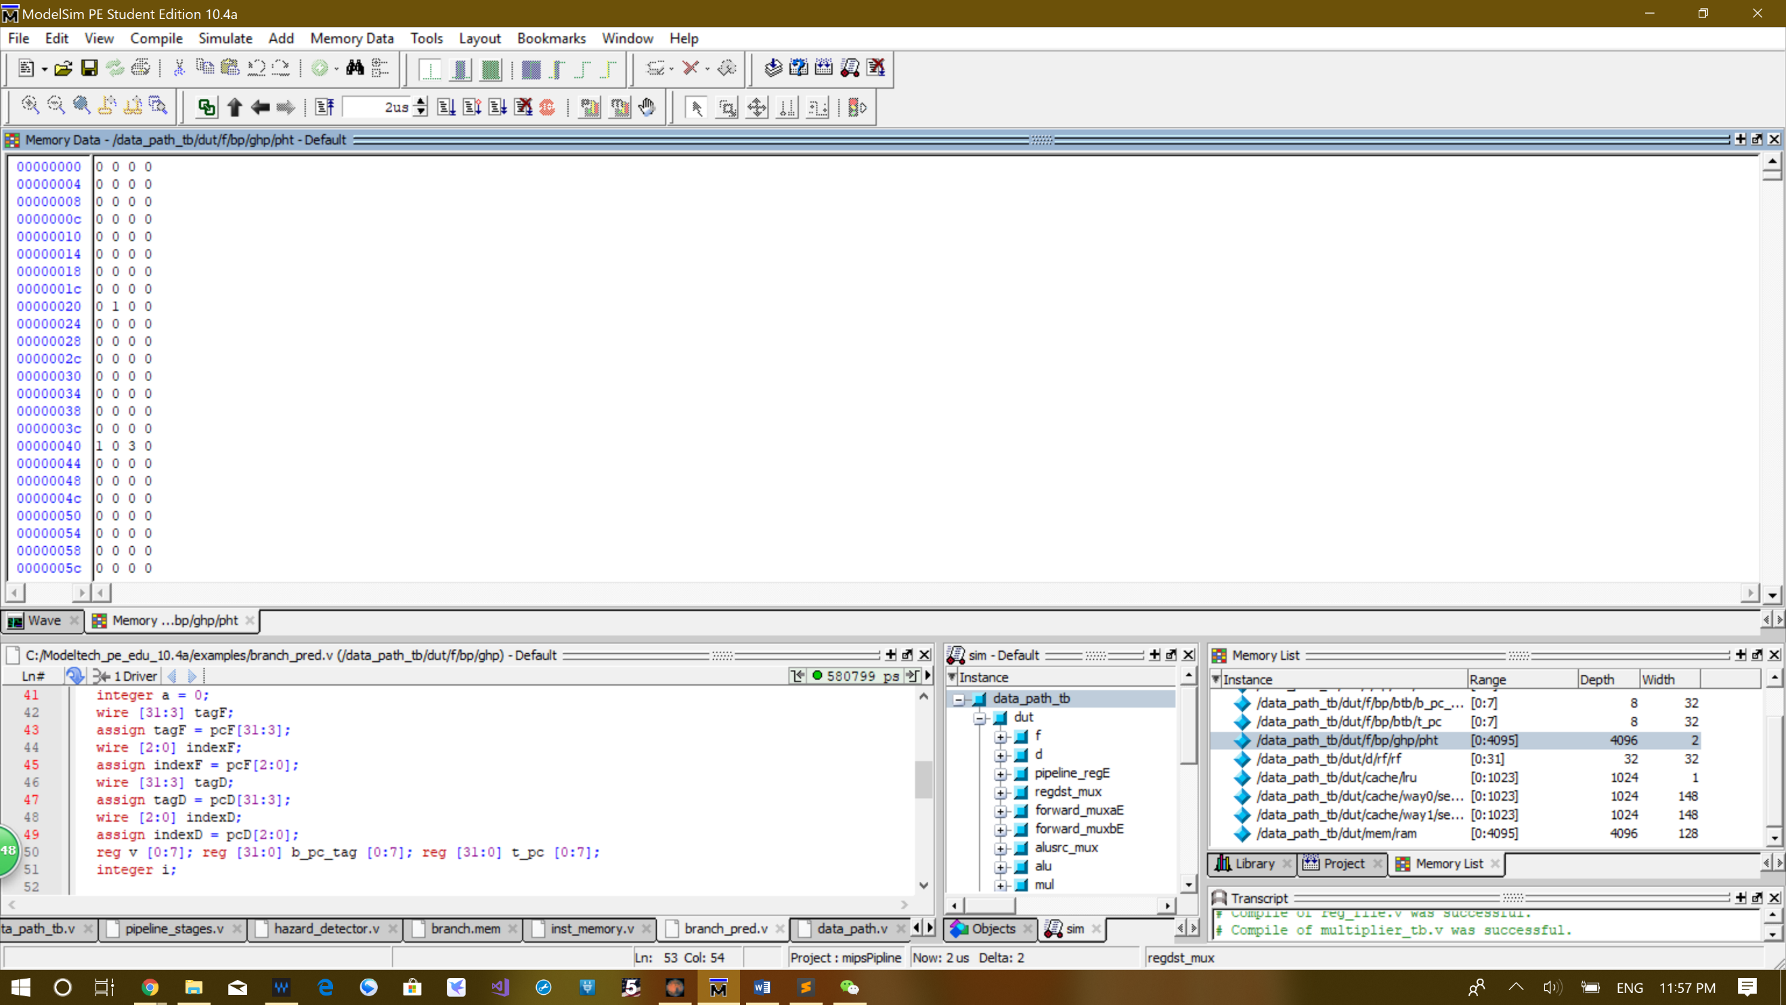

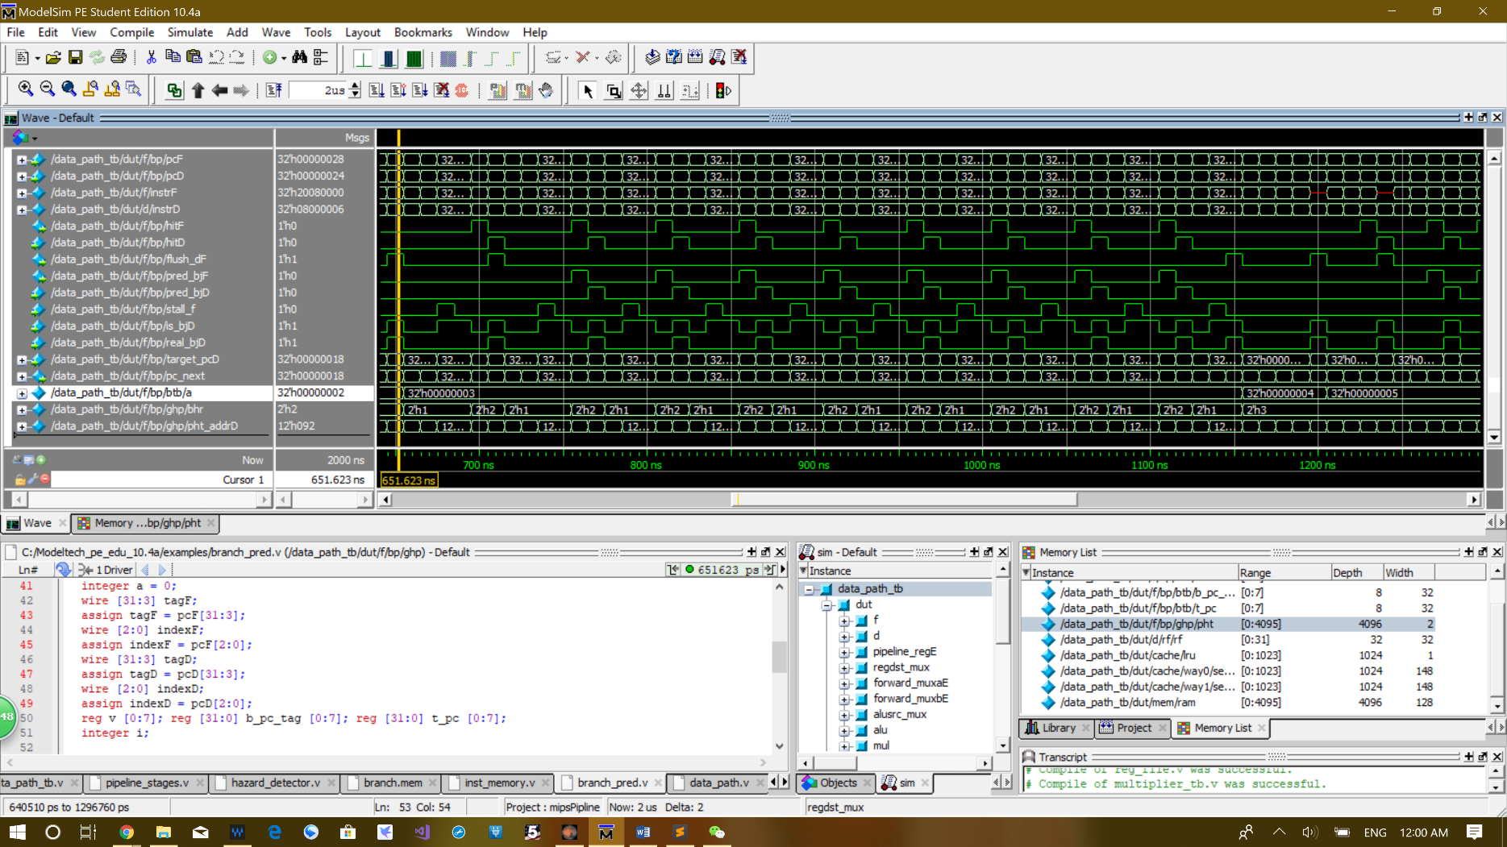As you can see a 1 is store in the address 20, because this is the only time this branch is taken, so the counter never gets incremented again.

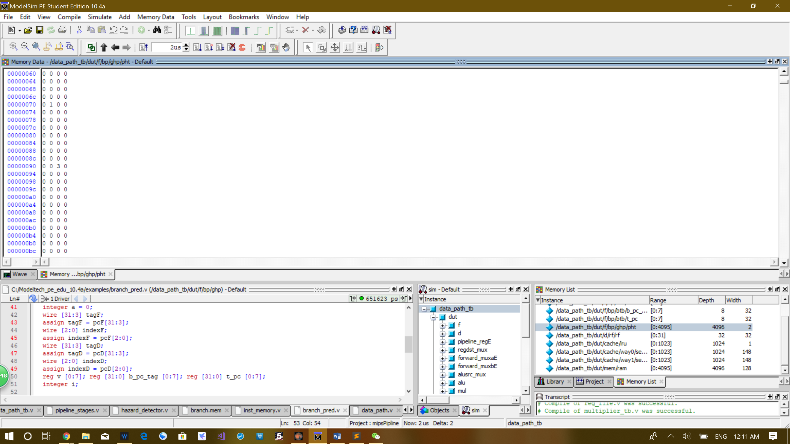The waveform above is the waveform of the second while loop which operates exactly the same as the first while loop except the instrutino is bne non beq. As you can see the waveform starts form a = 3 to a = 4 is exactly the same as the first while loop. The only difference is that it takes only 2 cycles to warm up, because the bhr already have the value 2 in it after the last while loop, since both jump and beq are taken. The first jump of the second while loop is stored in the address 92 of the pattern history table which is generated by combining the last 2 bits of the bhr and the last 10 bits of pcD.

As you can see a 3 is stored in the address 92 for the jump in the second while loop. Since the bhr value is already 11 when entering the second while loop, this is the only place where the counter for this jump is incremented. Since it is a jump and never not taken, the count stucks at 3 in the end.

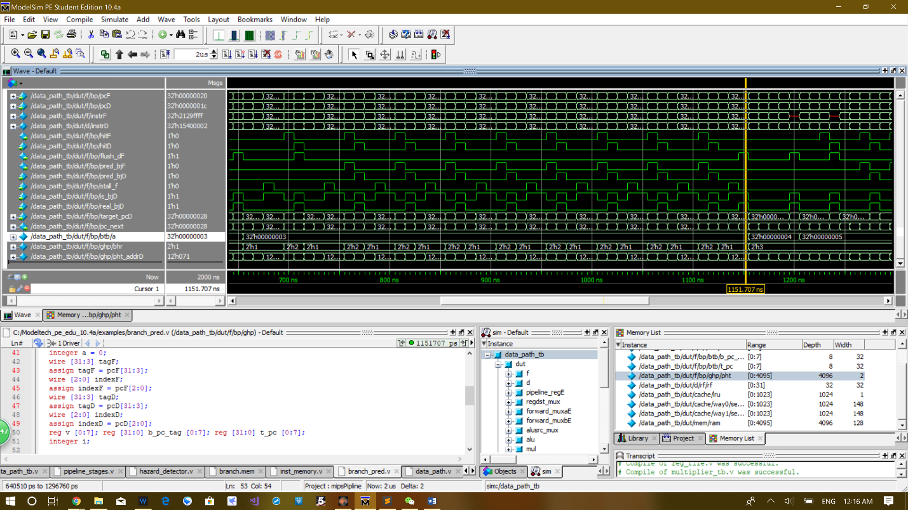

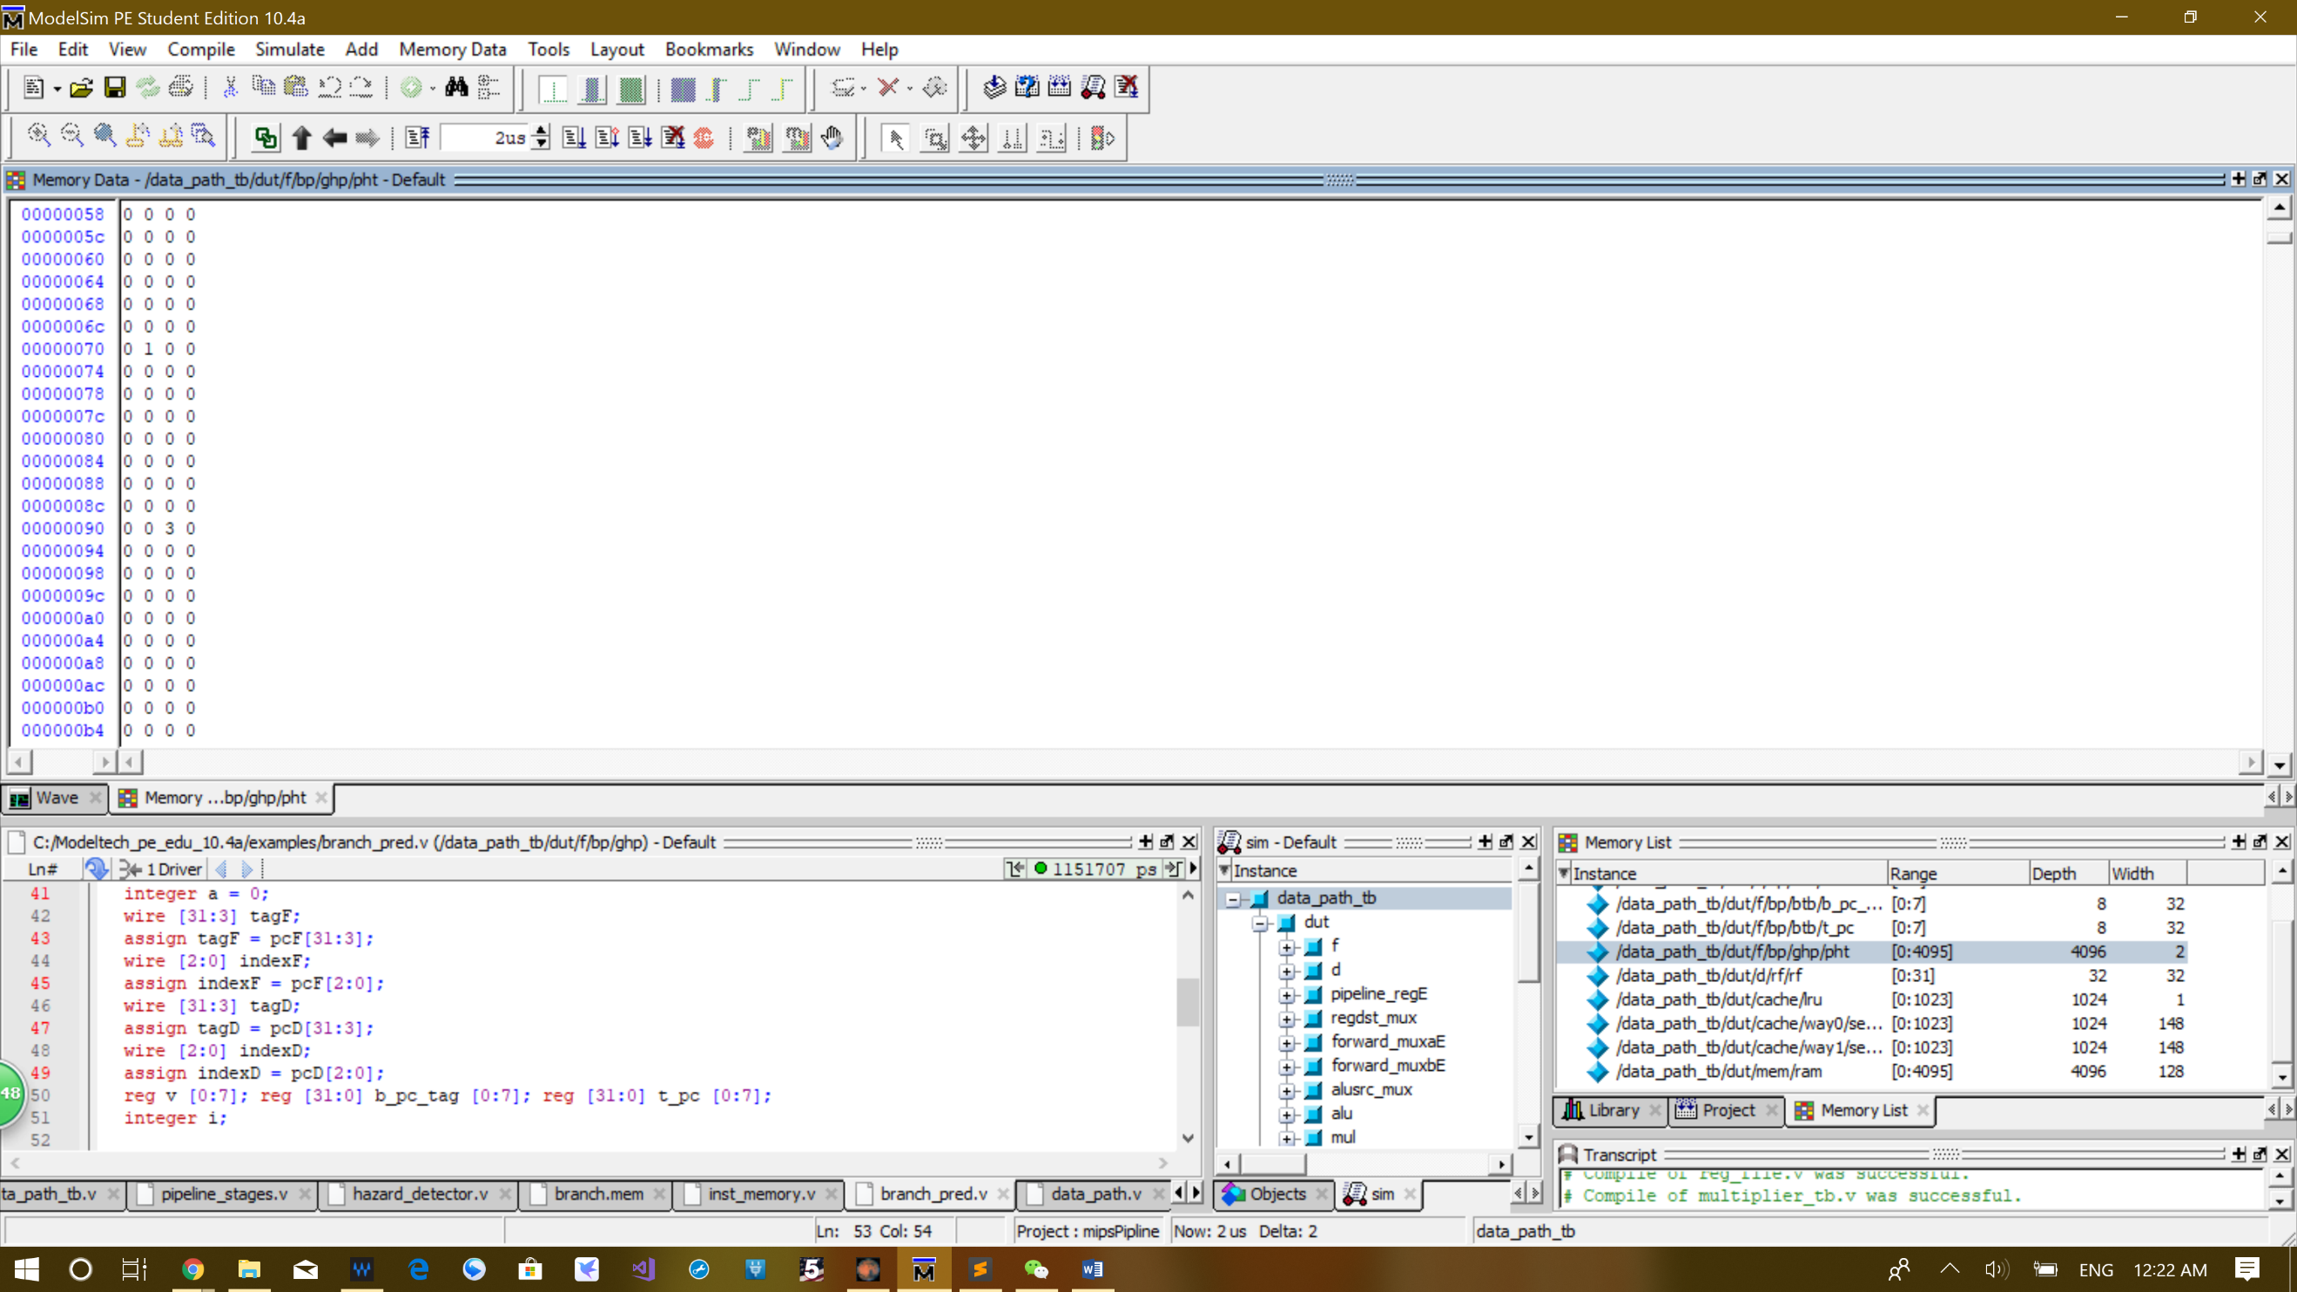After taking 10 jumps, the bne is finally taken and the counter in the pattern history table is incremented by 1. As you can see the the value of the pattern history table is increment at address 71.

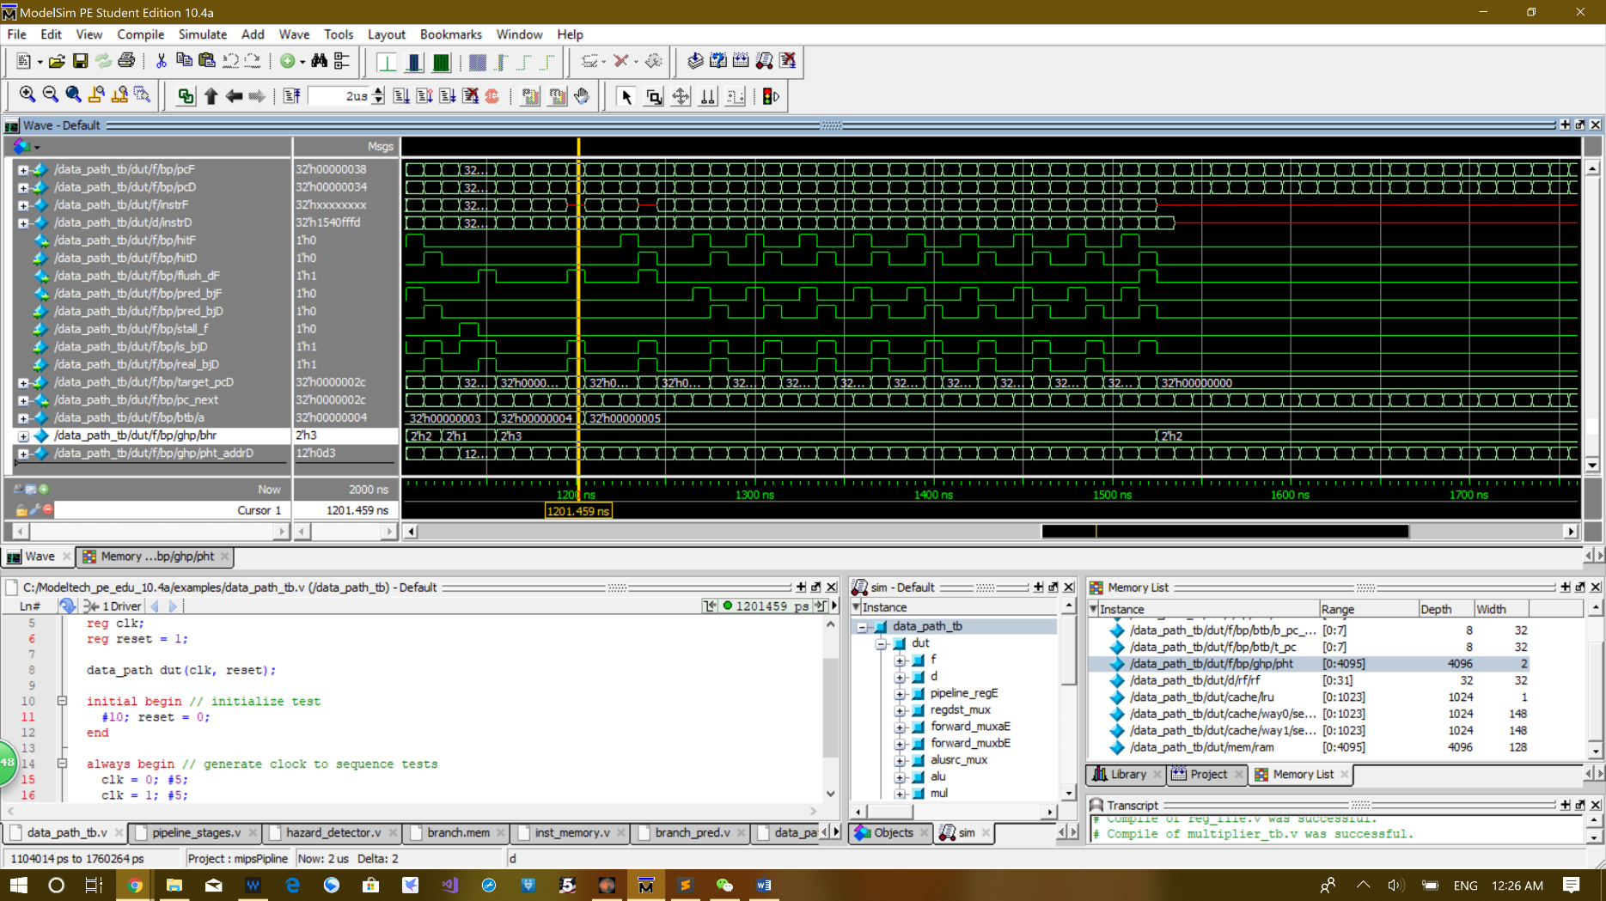There is only a one store in there because the bne is only taken 1 time, so the entry is never incremented again.

The last while loop only have a bne at the end of the loop, which means there are no jumps in this loop. All first 9 times of bne are taken and the last time of the bne is not taken. As you can see from pred_bjD signal, the warming up takes two times, since the first two times the signal is_bjD becomes one the signal pred_bjD is 0. The next 7 bne all gets predicted correctly.

The value of pattern history table at address d3 is increament for every time the bne instrution in decode stage. The bhr value is always 3, because last 2 branch and jump instruction in the second while loop is all taken.

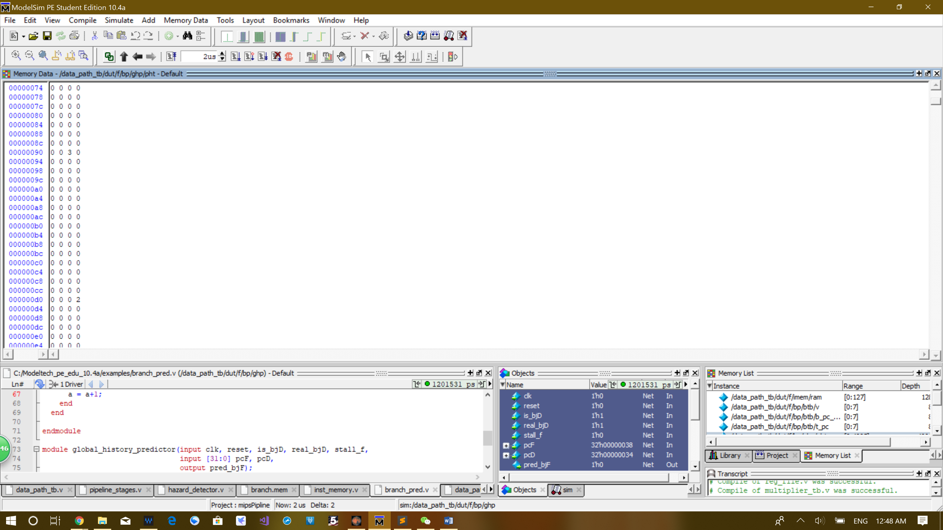The last bne is predicted to be a branch, but it is not, so the counter in the pattern history table gets decremented to 2 at the last cycle.

**Conclusion:**

In this project, we implemented the design in the **Extra Credit**, which is target address cache with 2^3 entries and decoupled branch target history table with 2^12 entries. The target address cache and the target history table are implemented as separate module in the branch prediction module.

Time spent: around 24 hours.